# Exercises: Introduction to Databases

This document defines the **exercise assignments** for the ["Databases Basics - MSSQL" course @ Software University.](https://softuni.bg/trainings/3714/ms-sql-may-2022)

## Create New Database

* Connect to the Server with Authentication Mode

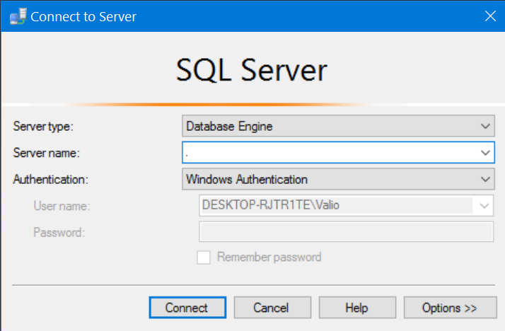

* Create a new database

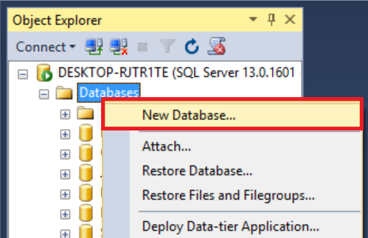

* Type the name of the database and click OK. This will create your database.

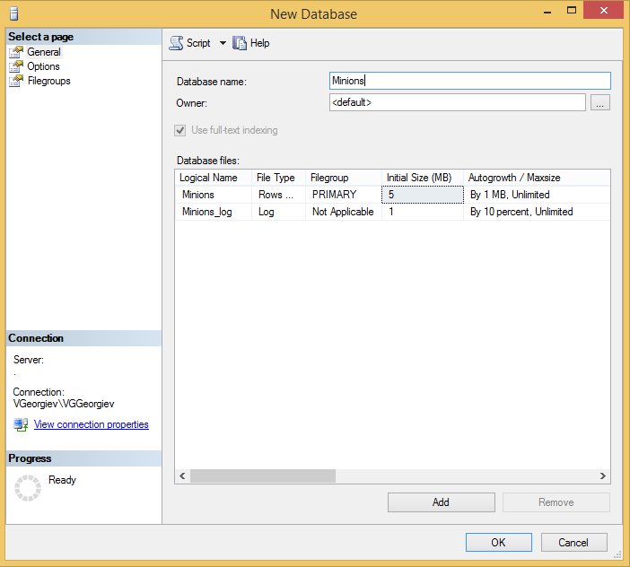

## Create Table

* Create **table** **Minions**

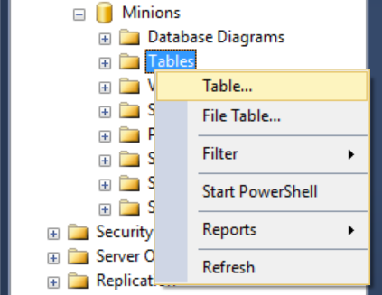

* Create columns **Id, Name, Age**. Id and Name are **required**; Age should **allow null values**.

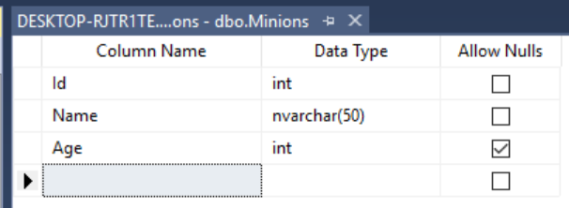

* Set the **Id** as a **primary key**.

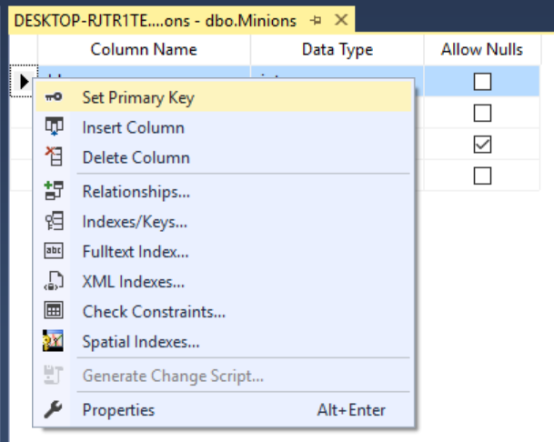

## Insert Data in the Table

Insert data in the table as it is shown on the picture

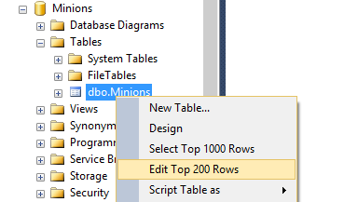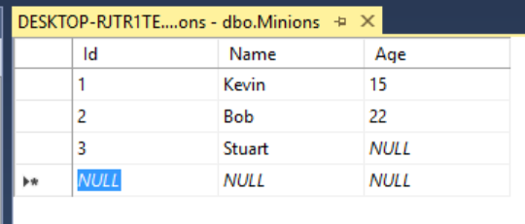

## Select Data from Table

* Select all columns from the Minions table.

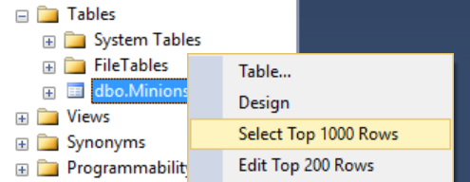

* Open a new query window, then write the SQL.
  + * Select **only Names** from the Minions table.
  + ** **Order** them **ascending by name**

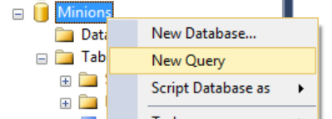

## Update One Record

Change **Stuart’s age** from **NULL** to **10**



## Update All Records

Change the age of all Minions to be + 1 year.

## Delete Record

Open the table in Edit Mode, **right click** on the row where **Bob** is situated and delete it.

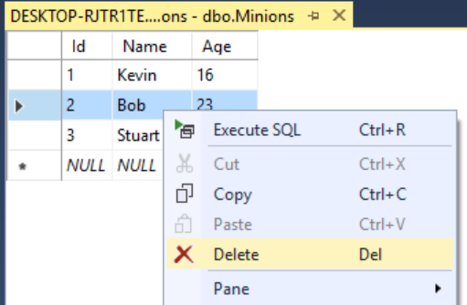

## Create New Table

Create a new table **Towns**. Every town has **Id (int)** and **Name (text)**. Make the **Id** column a **primary key**.

## *Connect Tables

Now let’s make a connection (or relationship) between our two tables. First we need modify our Minions table. Add a column **TownId** in it **(IMPORTANT: The type of the column must be the same as the type of the column Id of the Towns table)**.

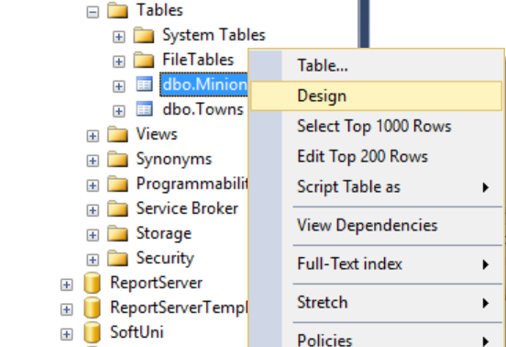

Now we can make a new diagram. The diagram shows all tables and the relationships between them.

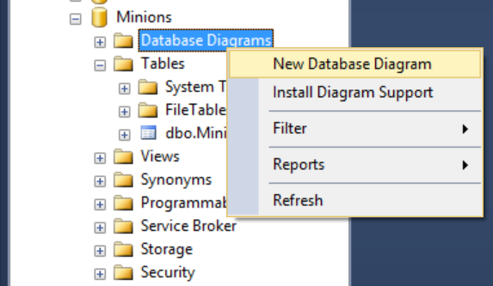

Select all tables to be on the diagram and click **Add**

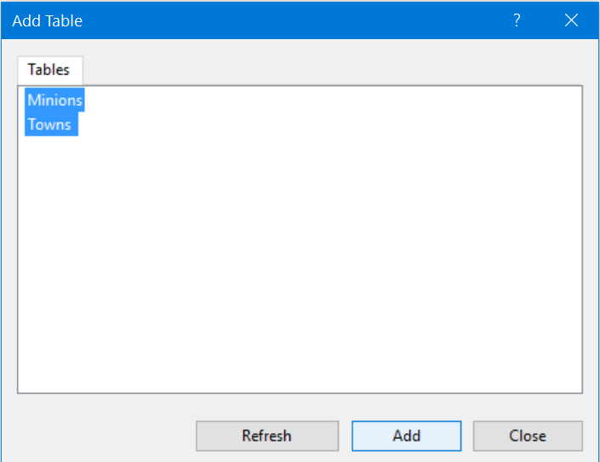

Finally, simply drag the **TownId** column and drop it on the Id column in Towns. Then Make sure the window looks like this and click OK.

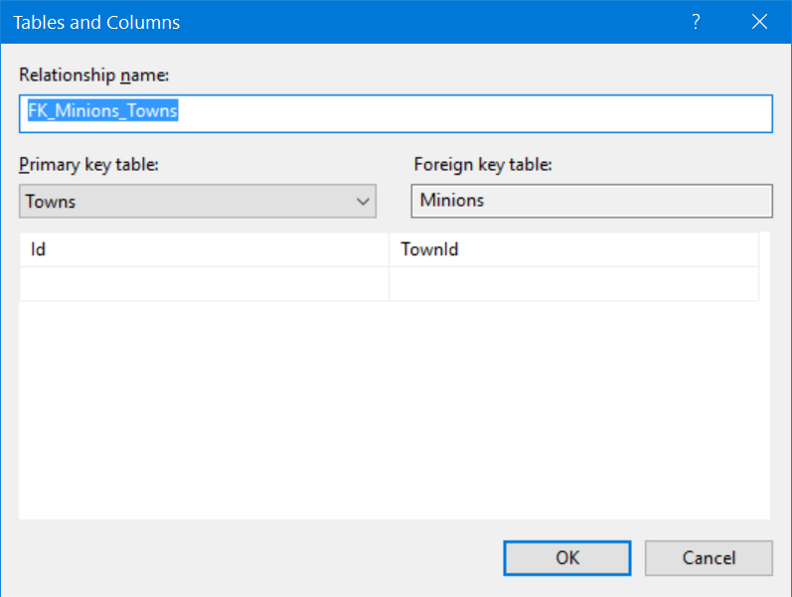

That’s all. Now the two tables have a relationship between them.

## Create New Database

Now, on your own, create a new database **School**. Add a few tables to the database: **Students (Id, Name, Age, PhoneNumber)**, **Classes (Id, Name, MaxStudents), Teachers(Id, Name, Class)**. Add columns for the tables. Populate the tables with a random content. Then delete and make changes in some records.

## *Generate SQL Script

Generate SQL script from the **School** database. View the script file and try to understand the different commands. Execute the script.